CALCULATION AND VERIFICATION OF FREQUENCY DEVIATION AND MODULATION INDEX OF FM SIGNALS USING MATLAB SIMULATION
Objectives:
1. To generate a Frequency Modulated (FM) signal in MATLAB using specified carrier and message signal parameters.
2. To calculate and verify the frequency deviation of the FM signal from the given carrier frequency and modulating signal parameters.
3. To determine and verify the modulation index of the FM signal using the relationship between frequency deviation and message frequency.
4. To analyze the effect of message frequency on frequency deviation and modulation index, and verify their relationship through MATLAB simulation
PROGRAM (MATLAB CODE)
% Calculation and Verification of Frequency Deviation
% and Modulation Index of FM Signal
clc;
clear;
close all;
%% Message Signal Parameters
Am = 2; % Message amplitude (V)
fm = 500; % Message frequency (Hz)
%% Carrier Signal Parameters
Ac = 1; % Carrier amplitude (V)
fc = 10000; % Carrier frequency (Hz)
%% FM Parameters
kf = 250; % Frequency sensitivity (Hz/V)
fs = 100000; % Sampling frequency (Hz)
T = 0.01; % Simulation duration (s) %% Time Vector
t = 0:1/fs:T;
%% Message Signal
m = Am*cos(2*pi*fm*t);
%% Frequency Deviation
delta_f = kf*Am;
%% Modulation Index
beta = delta_f/fm;
%% FM Signal
fm_signal = Ac*cos(2*pi*fc*t + beta*sin(2*pi*fm*t)); %% Display Parameters
fprintf('Carrier Frequency (fc) = %.0f Hz\n',fc); fprintf('Message Frequency (fm) = %.0f Hz\n',fm); fprintf('Message Amplitude (Am) = %.0f V\n',Am); fprintf('Frequency Sensitivity (kf) = %.0f Hz/V\n',kf);
fprintf('\nFrequency Deviation (Delta f) = %.2f Hz\n',delta_f); fprintf('Modulation Index (Beta) = %.2f\n',beta); %% Verification
beta_verify = delta_f/fm;
fprintf('Verified Modulation Index = %.2f\n',beta_verify); %% Verification Check
tolerance = 1e-6;
if abs(beta - beta_verify) < tolerance
fprintf('\nVerification Successful\n');
else
fprintf('\nVerification Failed\n');
end
%% Plotting
figure;
subplot(2,1,1);
plot(t,m,'LineWidth',1.5);
grid on;
title('Message Signal');
xlabel('Time (s)');
ylabel('Amplitude (V)');
subplot(2,1,2);
plot(t,fm_signal,'LineWidth',1);
grid on;
title('FM Signal');
xlabel('Time (s)');
ylabel('Amplitude (V)');
OUTPUT:
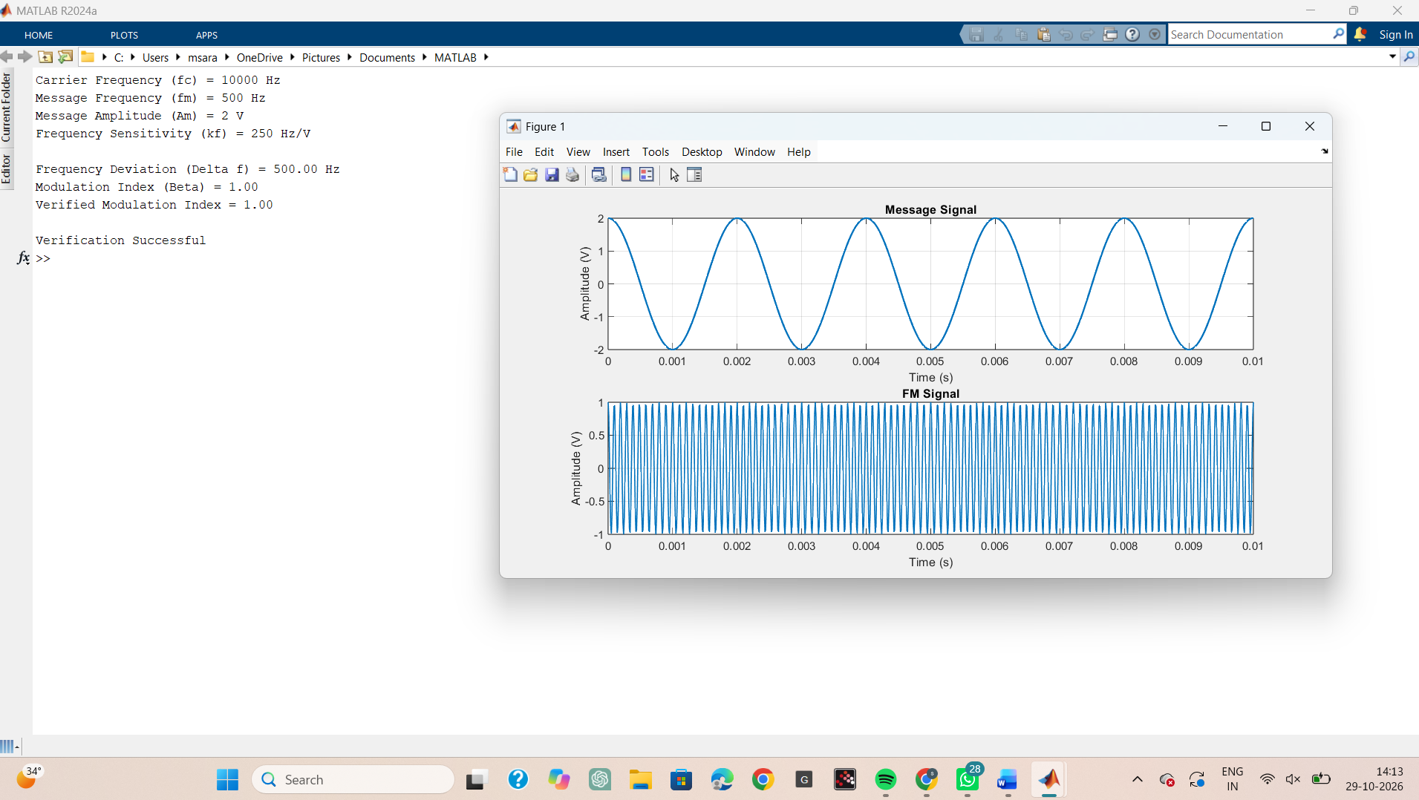
Result
1. Generate and visualize carrier, message, and FM signals using MATLAB.
2. Calculate the theoretical frequency deviation and verify it from the simulated FM waveform.
3. Calculate the FM modulation index and verify the relationship β = Δf/fm.
4. Interpret the effect of changing message frequency on modulation index and verify that, for constant frequency sensitivity and message amplitude, the peak frequency deviation remains constant.

